Kerry GAA players past and present
Answers
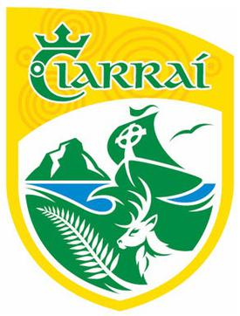
- Pat Spillane
- Jack O’ Shea
- David Clifford
- Kieran Donaghy
- Mikey Sheehy
- Paul Geaney
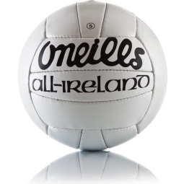
- Declan O’ Keeffe
- Shane Enright
- Colm Cooper
- Ger Power

